Lab: Gosu Enhancements

In this lab, you will create a Gosu enhancement for the ABContact entity and make related changes for various PCF Files.

First, you will create an enhancement for the ABContact entity related to analysis. The enhancement will contain a getter property and a method. You will then modify the ABContactAnalysisDV.pcf file to display the value of the getter property. Next, you will modify the ABContactAnalysisPage.pcf file. You will add a toolbar button to the toolbar. You will configure the button to call the enhancement method.

Requirements

This lab requires that you first complete labs from previous lessons including Extending Entities, Typelists, Atomic Widgets, Detail Views, and Editable Detail Views.

This lab requires that you use TrainingApp 8.0, Guidewire Studio 8.0, and a supported web browser. To view, edit, and delete various contacts, log in to TrainingApp as Alice Applegate. The default URL for TrainingApp is <http://localhost:8880/ab/ContactManager.do>. The login/password for Alice Applegate is aapplegate/gw.

1. Create an enhancement

At Acme Insurance, business requirements necessitate that all contacts of the type ABContact should receive a courtesy call once every six months. This information needs to appear with contact analysis details. In addition, business requirements require that there is easy way to upgrade contacts to the level of strategic partner.

Tasks

1. Open Guidewire Studio for TrainingApp
2. From Studio, if your server is not already running, start the server using Debug 'Server'.
3. Review the Debug console for errors and verify that the application is running in the Debug console.
4. In Guidewire Studio, create the package and the enhancement
5. In Guidewire Studio, create a package called acmelab.ta.enhancements.entity.
6. Create an enhancement for the ABContact entity that conveys that this enhancement relates to analysis.
7. Create a getter property named NextCourtesyContact()
8. Create a getter property named NextCourtesyContact() that returns a date that is six (6) months in the future of the Last Courtesy Contact date. If Last Courtesy Contact date is null, then the property must return null.
9. Create a method named upgradeToStrategicPartner()
10. Create a method named upgradeToStrategicPartner() that, for a given contact, does the following:
    * Sets the IsStrategicPartner_Ext field to true.
    * If the value of the CustomerRating_Ext field is null, sets the value to 25.
    * If the value of the CustomerRating_Ext field is between 0 and 989.9, increments that value by 10.
    * If the value of the CustomerRating_Ext field is more than 989.9, sets the value to 999.9.
11. Modify ABContactAnalysisDV
12. In Studio, open ABContactAnalysisDV.pcf.
13. Modify the Strategic Partner widget to be read-only.
14. Add the appropriate read-only input widget below Last Courtesy Contact.
15. Create a displaykey for the widget's label property that reads Next Courtesy Contact.
16. Configure the widget to display the enhancement property value.
17. Modify ABContactAnalysisPage
18. In Studio, open ABContactAnalysisPage.pcf.
19. In the existing toolbar, add a toolbar button.
20. Create a displaykey for the button's label property that reads Upgrade to Strategic Partner.
21. Configure the toolbar button so that it calls the upgradeToStrategicPartner() method when clicked.
22. Configure the button so that it is only clickable when the contact is not a strategic partner and when the page is in edit mode.
23. Deploy your changes
24. Restart the server (Stop / Debug 'Server') in Guidewire Studio.

Verification

1. Verify the enhancement method and PCF behavior
2. Log in to TrainingApp as Alice Applegate.
3. Search for and open the Albertson's contact.
4. For the contact, navigate to the Analysis page.
5. Click Edit.
6. Set the Last Courtesy Contact field to today's date. Click Update.
7. Verify that the Next Courtesy Contact field shows a date that is six (6) months from today's date.
8. Search for and open the Albertson's contact.
9. For the contact, navigate to the Analysis page.
10. Verify that the Upgrade to Strategic Partner button is clickable only when the user is editing the page and the Strategic Partner field is not equal to Yes.
11. Verify that when the user clicks the Upgrade to Strategic Partner button, the Strategic Partner field equals Yes and that the Customer Rating field sets to either 25, 999.9, or its original value plus 10.

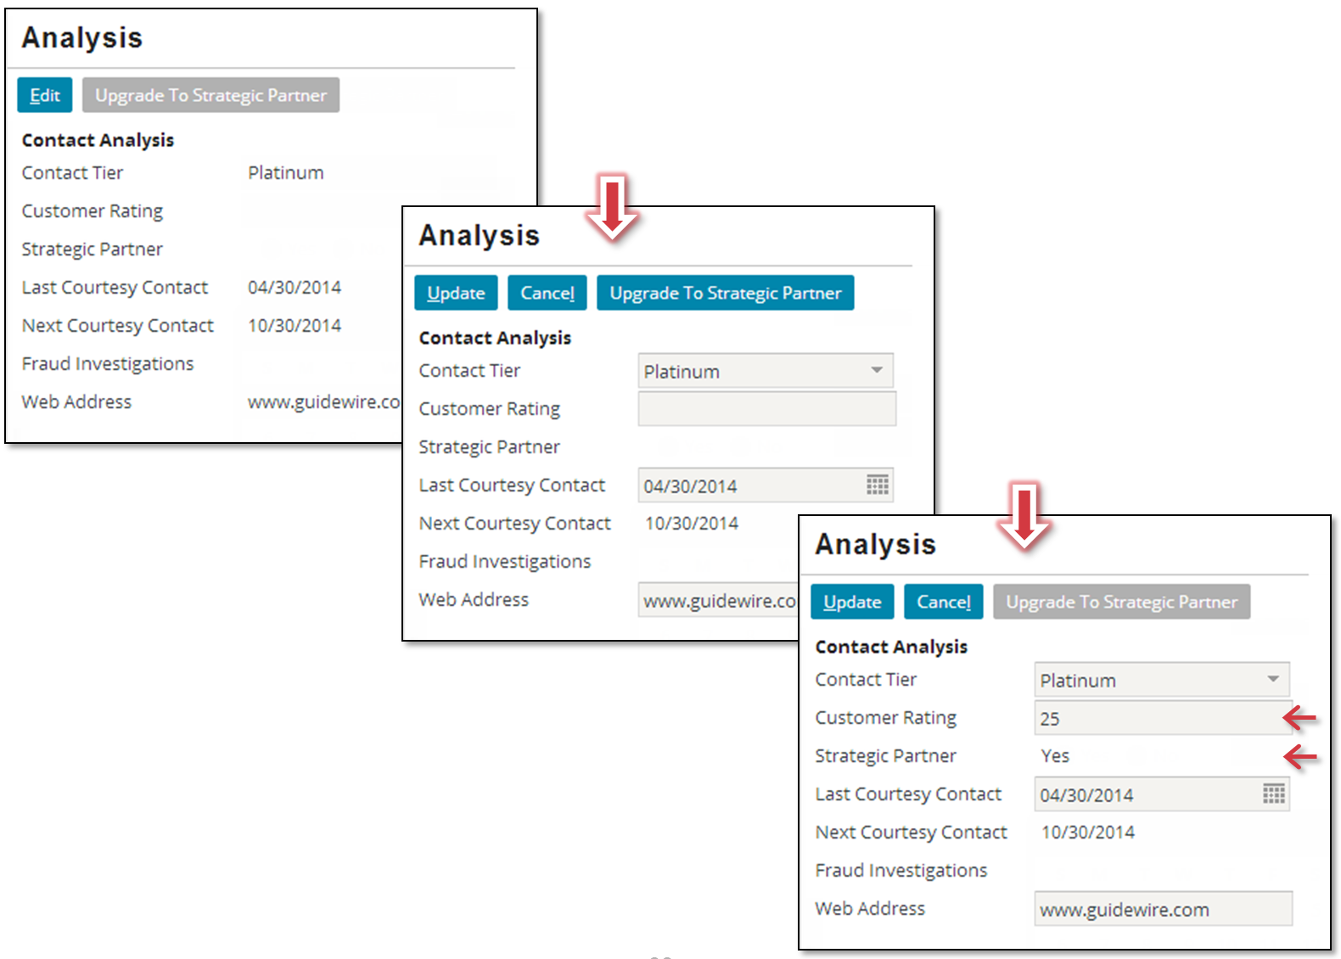

|  |  |
| --- | --- |
|  | Stop and ask your instructor to review your completed lab. |